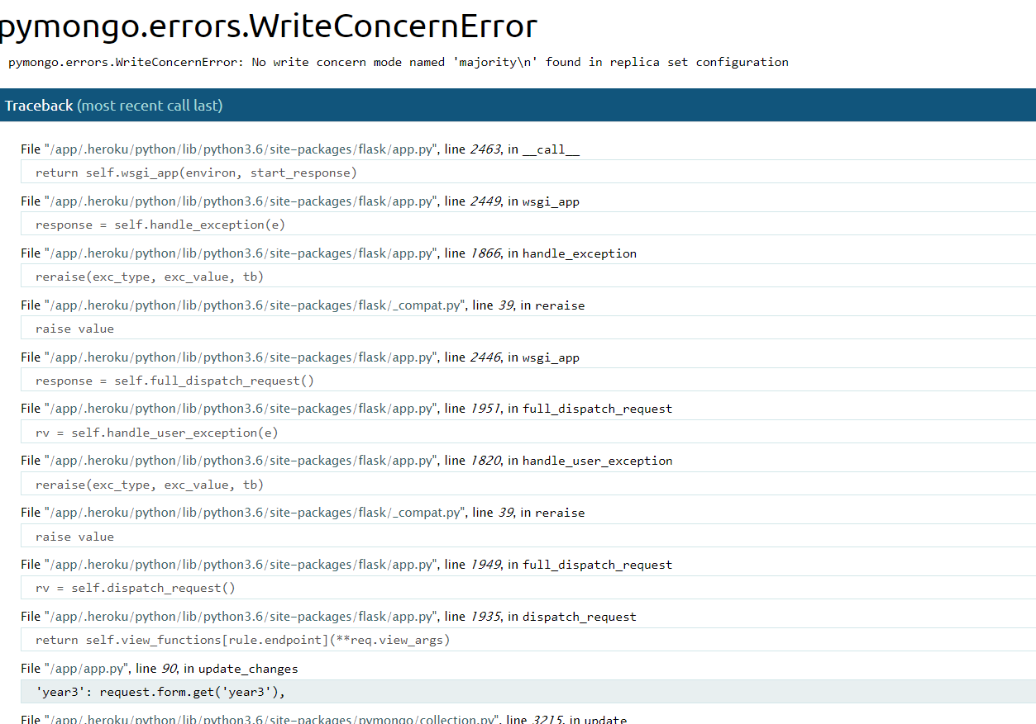
Found name=”year3” in edit_changes file.
Amended to summary.

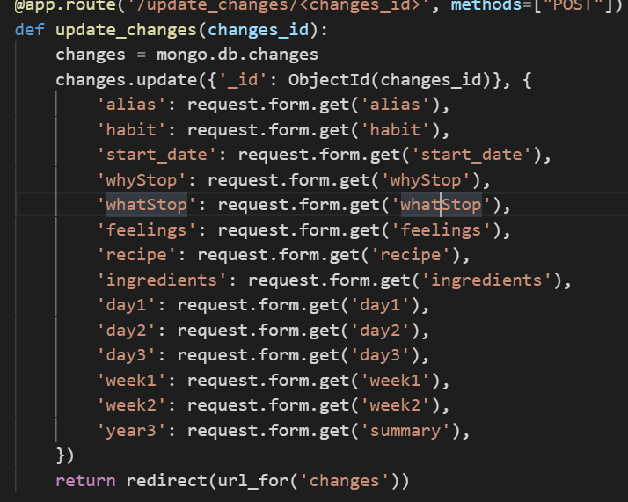

Getting null in mongoDB.

